TestRail – Day 2: Test Suites & Test Organization
Date: 25-Jan-2026
Learning Objective
• To understand test suites in TestRail
• To learn the difference between Single Suite and Multiple Suite modes
• To organize test cases effectively
• To create a test suite
1. Test Suite in TestRail
Definition:
• A test suite is a collection of related test cases organized under a common structure to improve test management and readability.
Learning Points:
• Helps organize large numbers of test cases
• Improves test maintenance and clarity
• Forms the foundation for test runs and plans
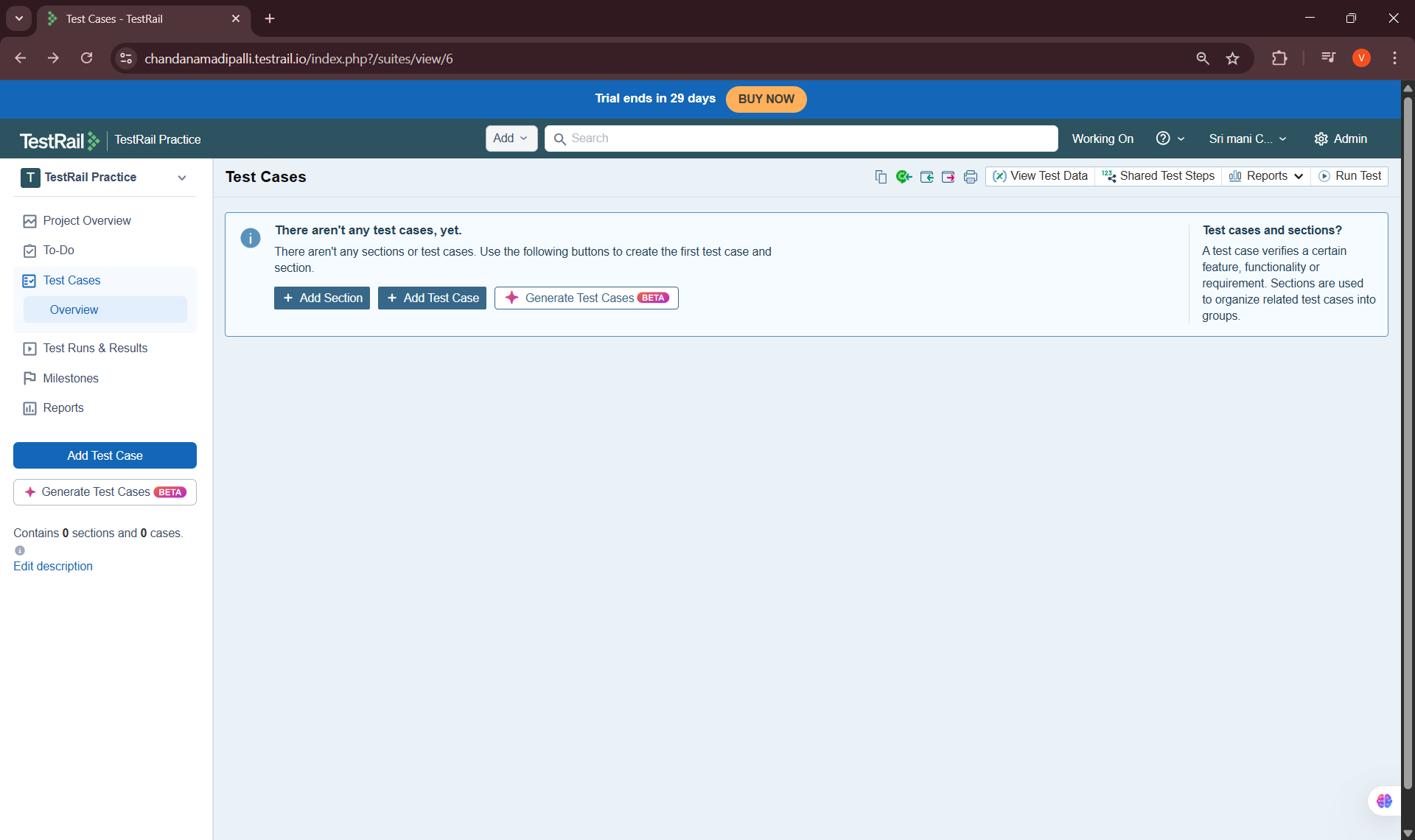
2. Single Suite Mode
Definition:
• Single Suite mode stores all test cases under one main suite without sub-suites.
Learning Points:
• Suitable for small projects
• Simple structure
• Easy to manage for learning and practice

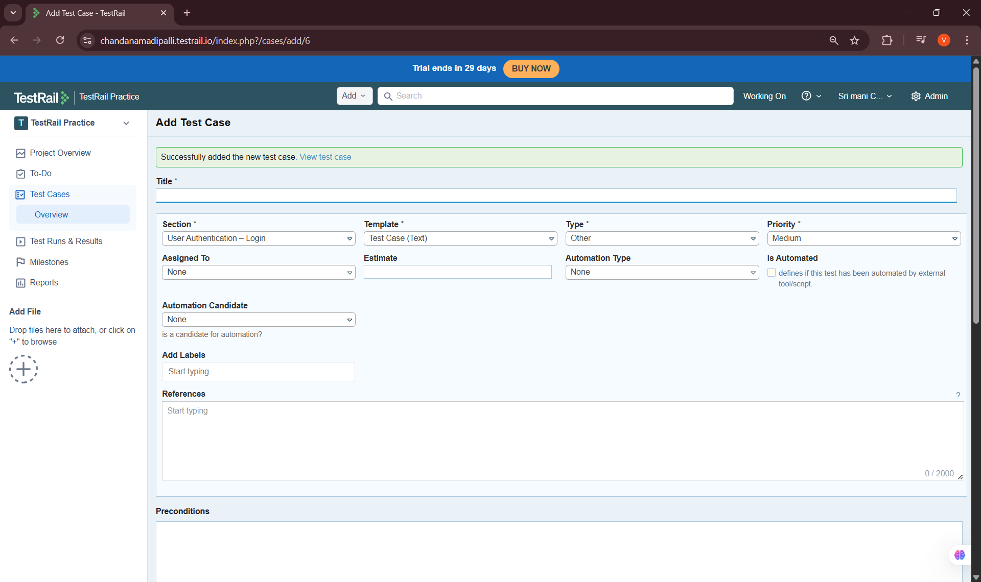

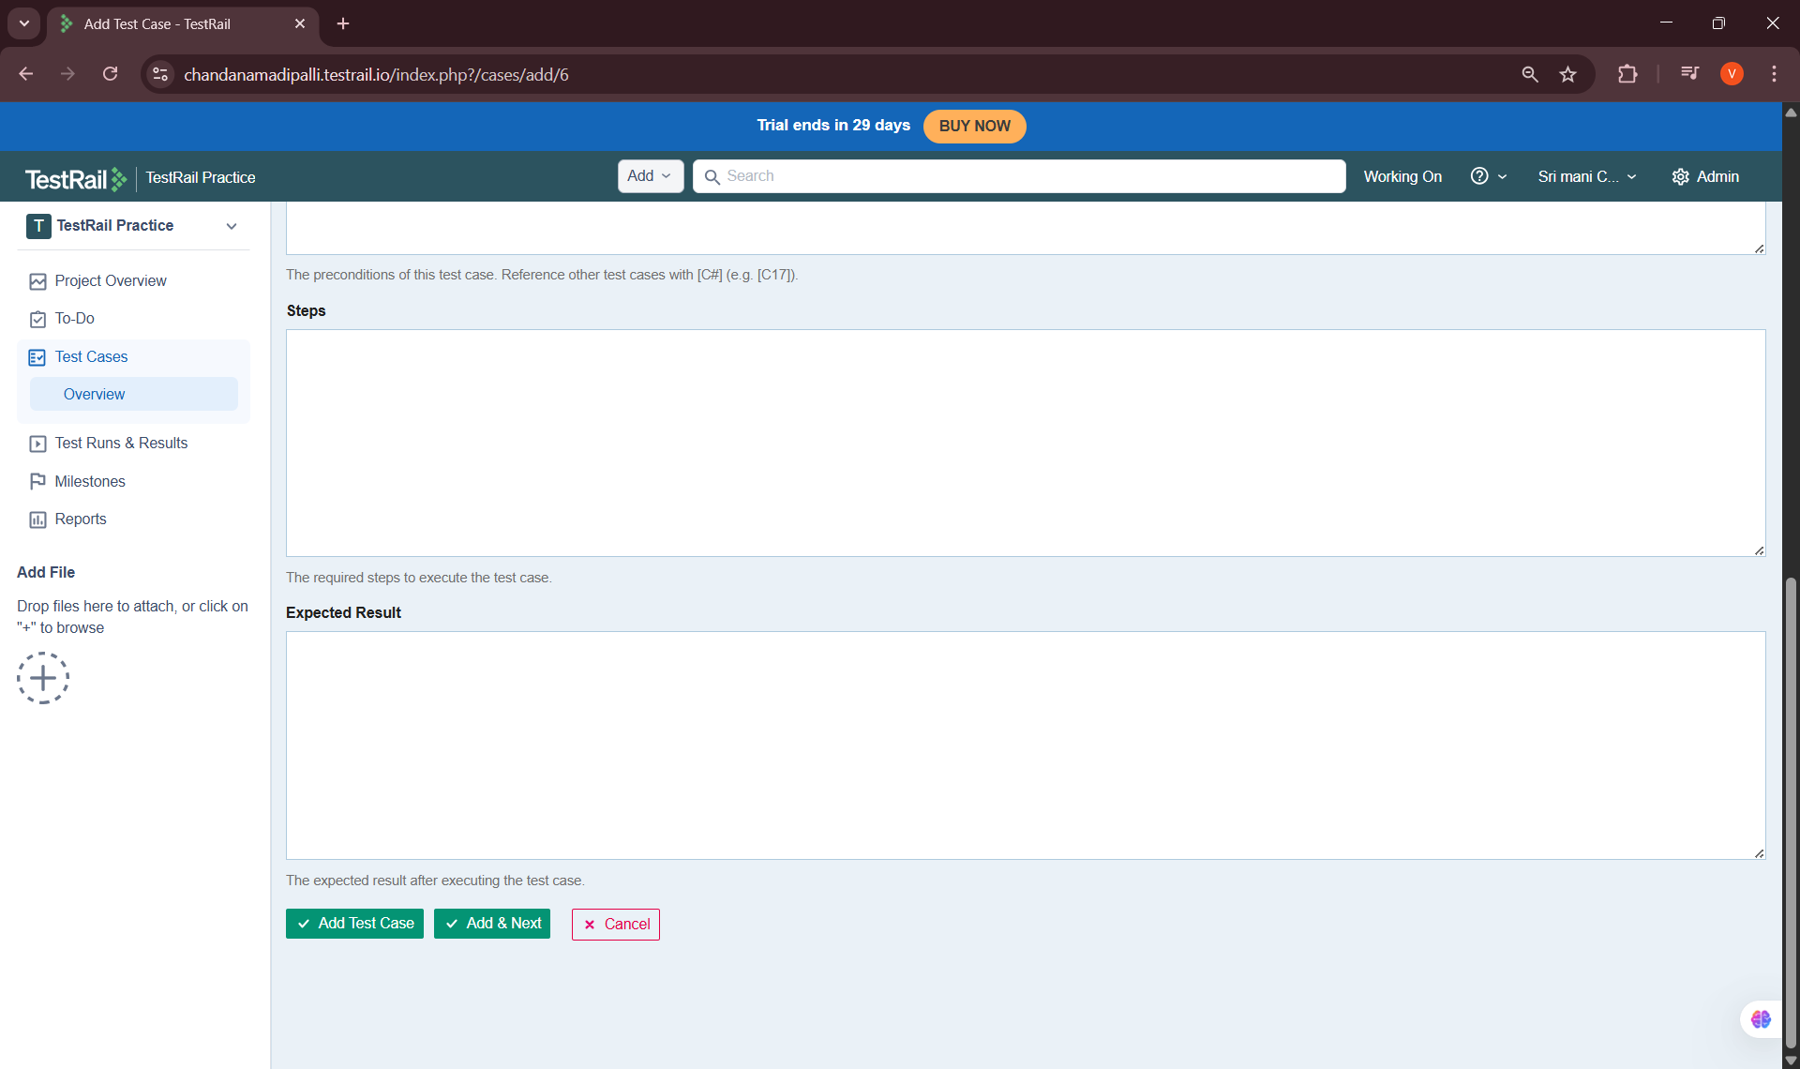

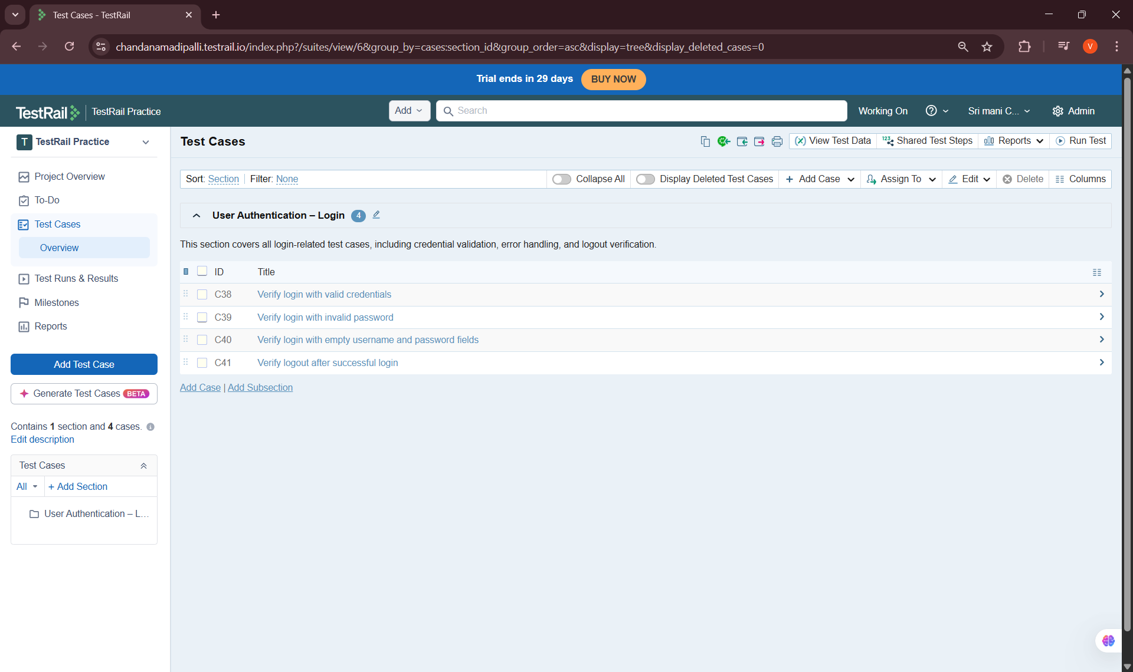
3. Multiple Suite Mode
Definition:
• Multiple Suite mode allows creation of multiple test suites and sub-suites for better organization.
Learning Points:
• Suitable for medium to large projects
• Supports modular test organization
• Improves scalability
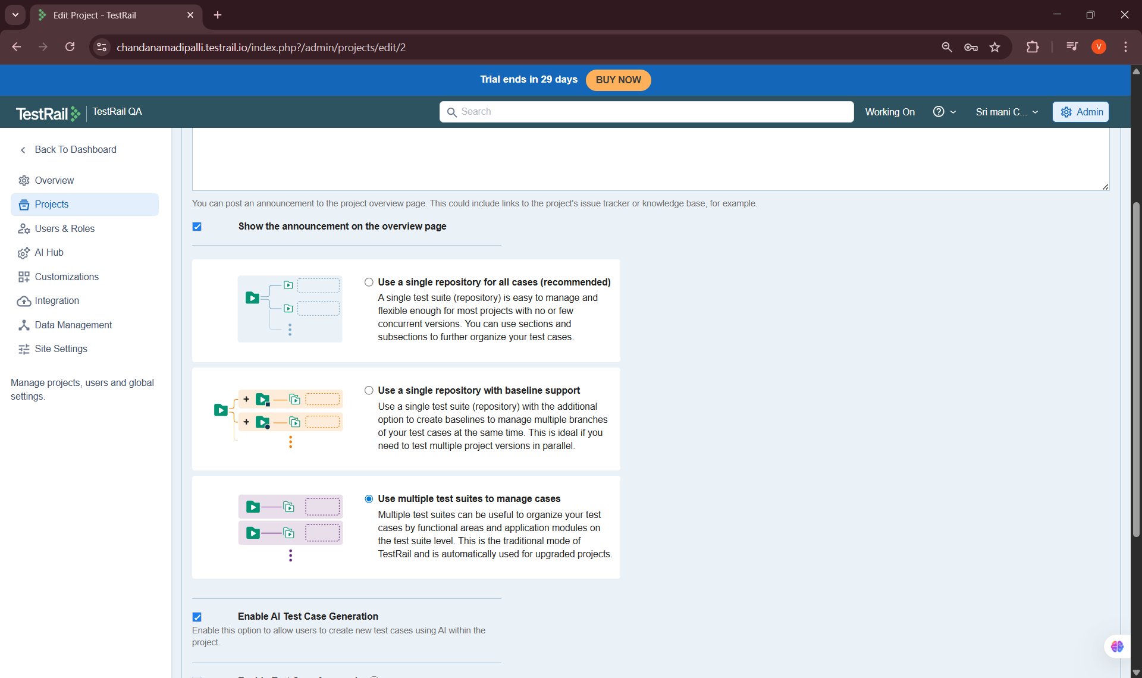

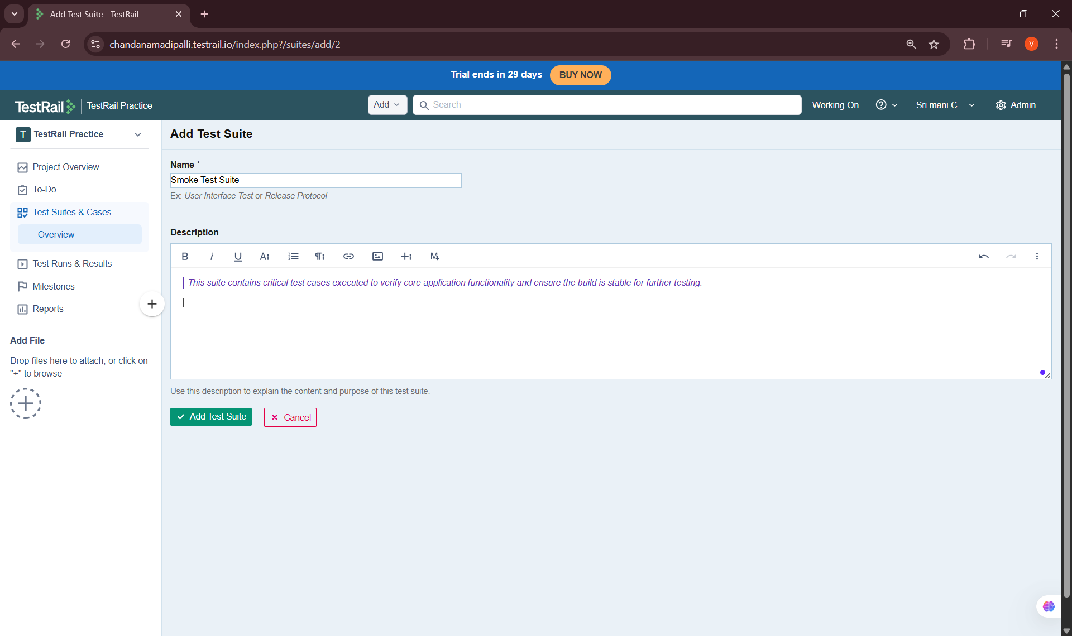

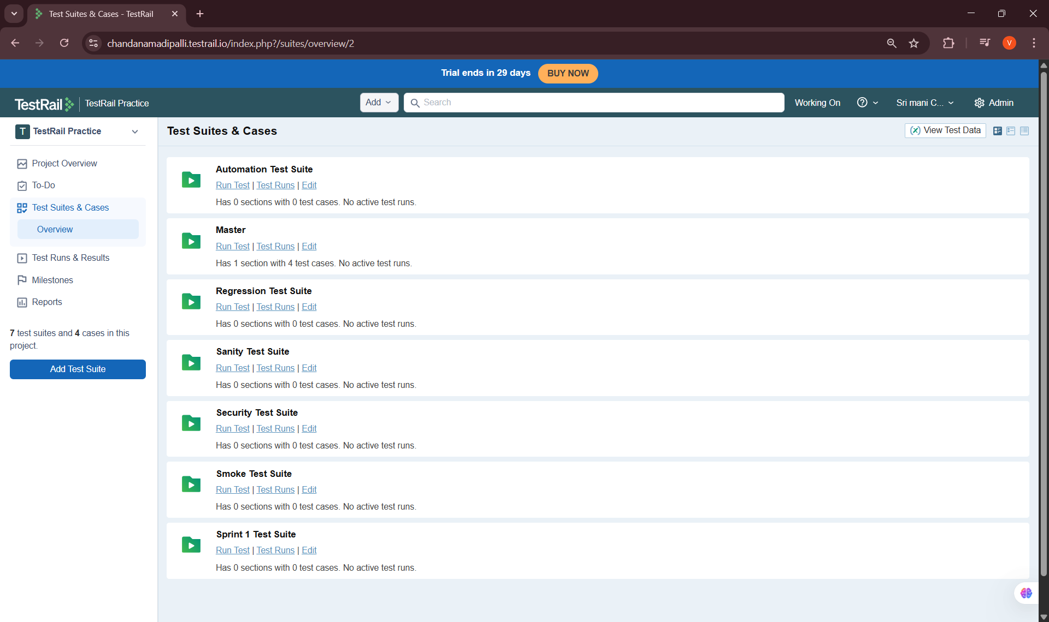
4. Organizing Tests Using Suites
Definition:
• Test organization involves grouping test cases logically based on modules, features, or functionality.
Learning Points:
• Organized tests by feature/module
• Improved test case discoverability
• Reduced duplication



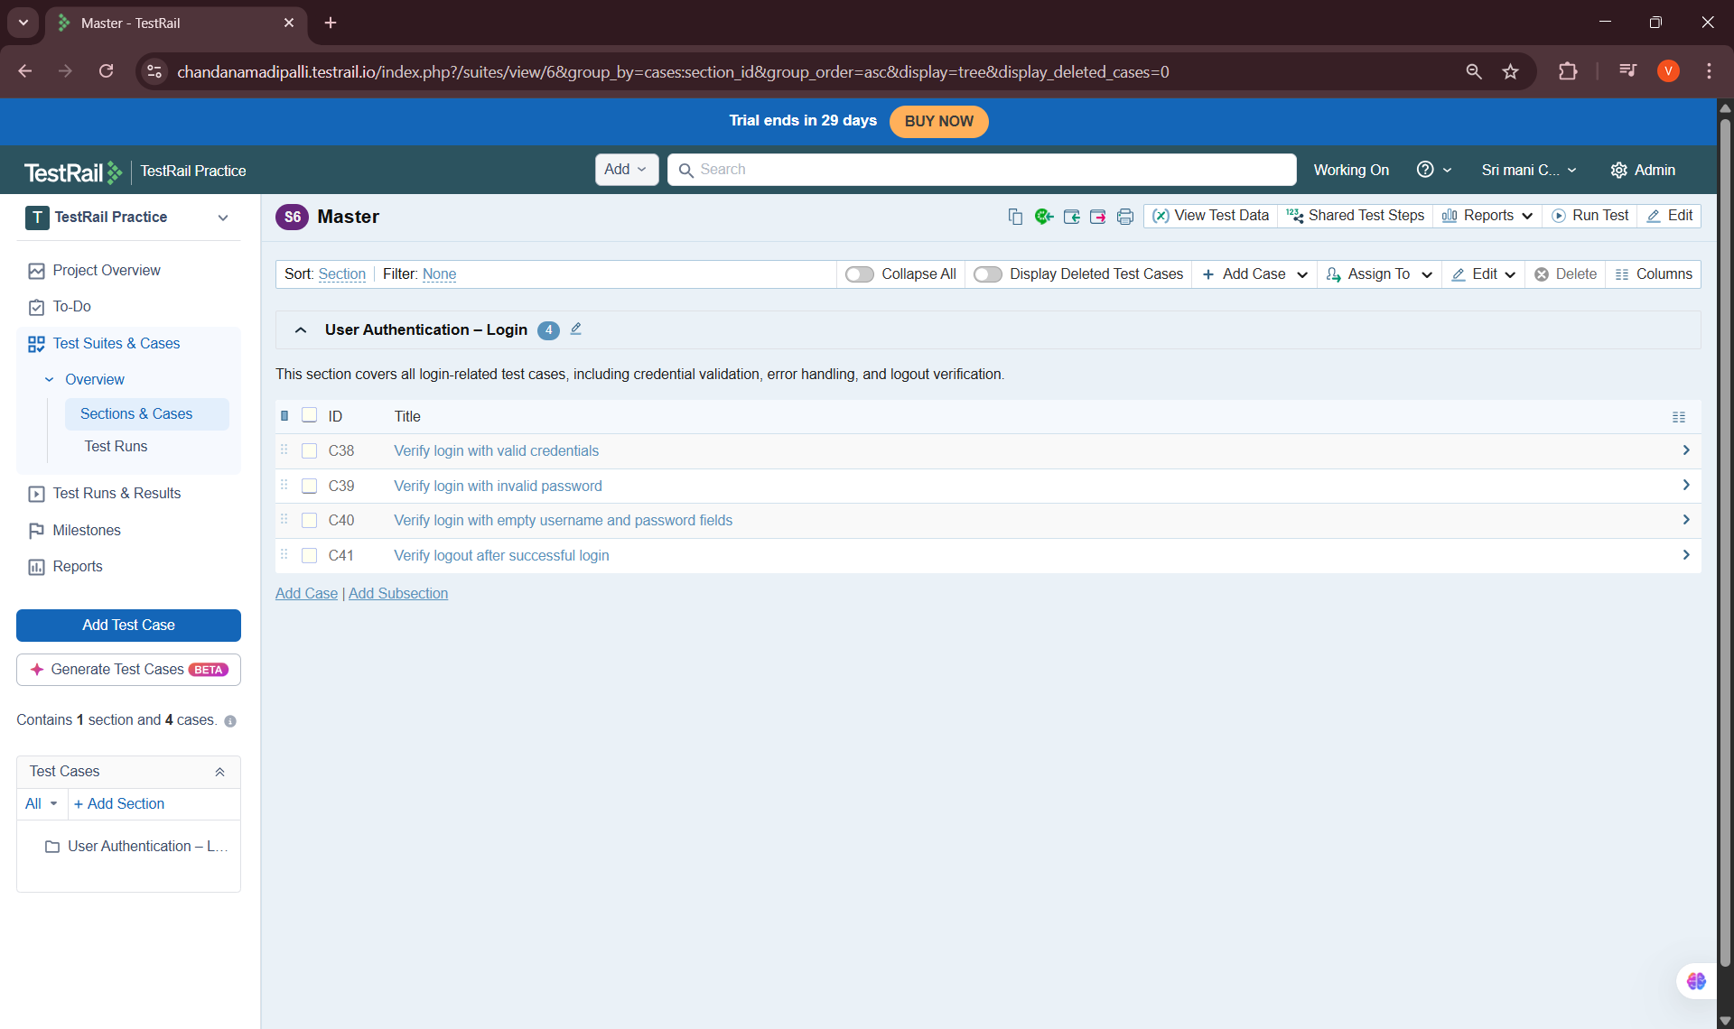
5. Creating a Test Suite
Definition:
• Creating a test suite involves defining a logical container for related test cases.
Learning Points:
• Created a new test suite
• Assigned a meaningful suite name
• Verified suite visibility within the project
Key Learnings & Outcomes
• Understood the concept of test suites in TestRail
• Learned differences between single and multiple suite modes
• Gained hands-on experience organizing test cases
• Successfully created and managed a test suite
• Built a structured foundation for test case creation

